CEE 691-001 Homework #9
Shibo Wang April 10,2008
18.4
Solution:
error function: 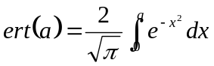
(a). two-point Gauss-Legendre formulas: upper limit b=1.5, lower limit a=0
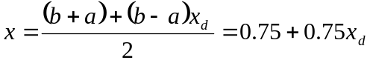
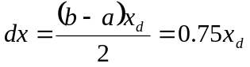
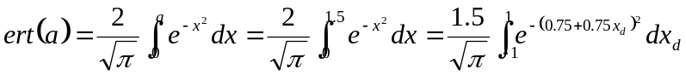
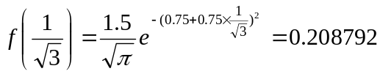
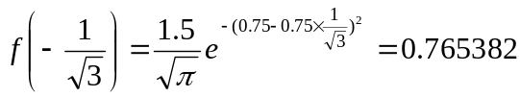
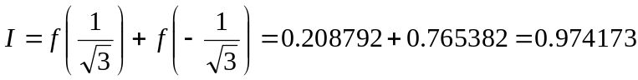
True value by running Matlab:
>> erf(1.5) ans =0.9661
Percent relative error: 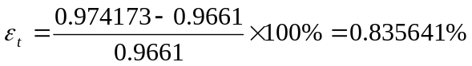
(b). three-point Gauss-Legendre formulas: upper limit b=1.5, lower limit a=0
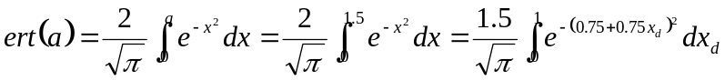
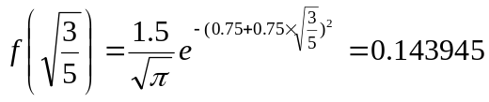
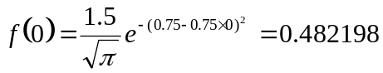
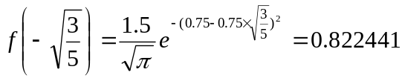
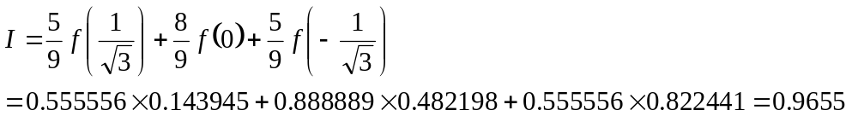
Percent relative error: 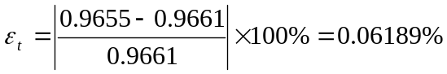
18.5
Solution:
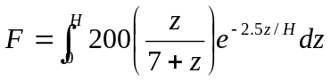
H=30
(a). Romberg integration to a tolerance of e_{s} =0.5%
Segments | h | Integral
1 | 30 | 199.6662
2 | 15 | 685.8657
4 | 7.5 | 933.67035
8 | 3.75 | 1020.201
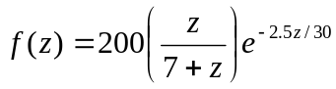
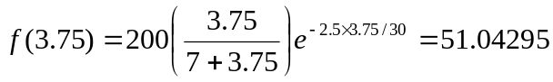
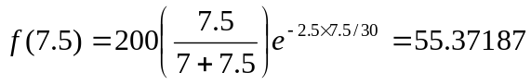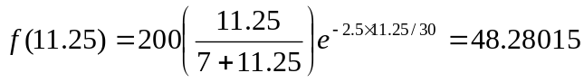
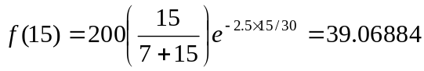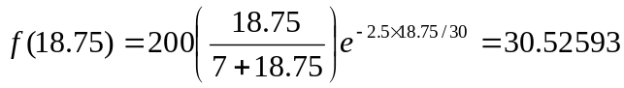
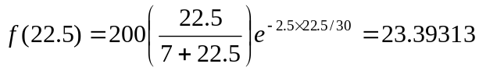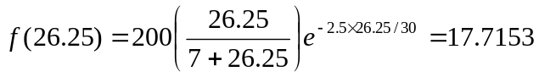
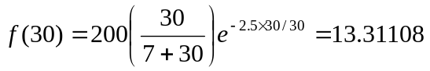
Using trapezoidal rule to calculate integrals,
n=1, h=30, 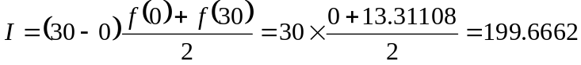
n=2, h=15,
n=4, h=7.5,
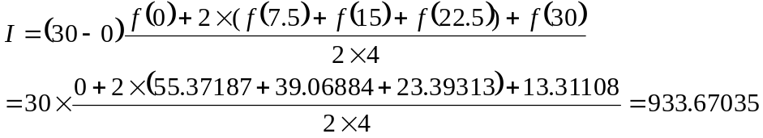
n=8, h=3.75,
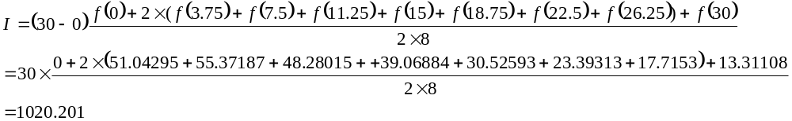According to Romberg integration:
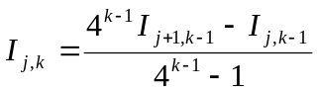
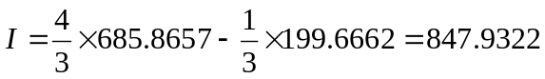
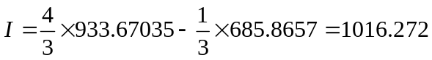
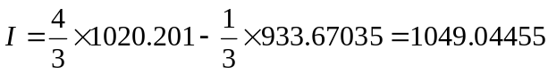
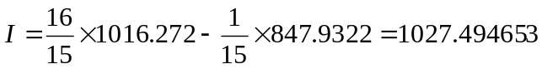
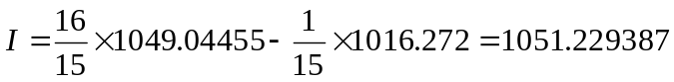
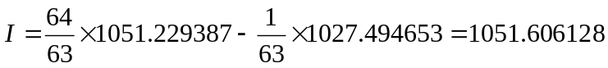

O(h²) | O(h⁴) | O(h⁶) | O(h⁸)
199.6662  685.8657 | 847.9322
199.6662  685.8657  933.67035 | 847.9322  1016.272 | 1027.494653
199.6662  685.8657  933.67035  1020.201 | 847.9322  1016.272  1049.04455 | 1027.494653  1051.229387 | 1051.606128
Tolerance: 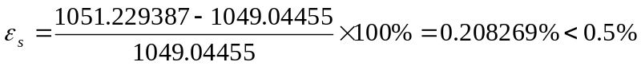
(b). two-point Gauss-Legendre formulas: upper limit b=30, lower limit a=0
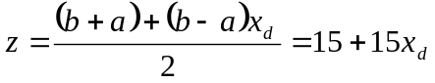
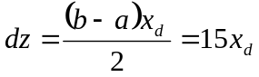
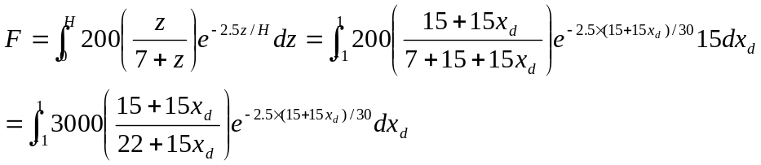
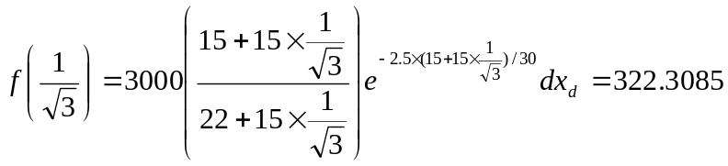
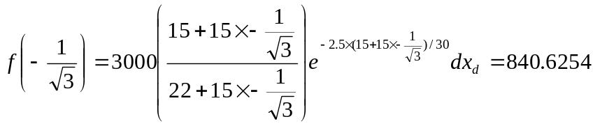
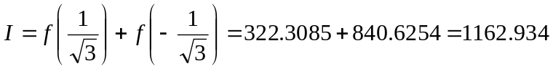
(c). Use Matlab to solve:
>> format long
>> func=@(z)200*(z/(7+z))*exp(-2.5*z/30)
func =
@(z)200*(z/(7+z))*exp(-2.5*z/30)
>> quad(func,0,30)
ans =
1.085280043451920e+003
18.7
Solution:
r₀=0.75 n=7 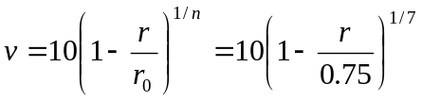
Flow:
(a). Romberg integration to a tolerance of e_{s} =0.1%
Segments | h | Integral
1 | 0.75 | 0
2 | 0.375 | 8.00475375
4 | 0.1875 | 11.55755
8 | 0.09375 | 13.142
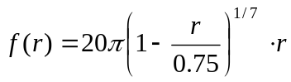
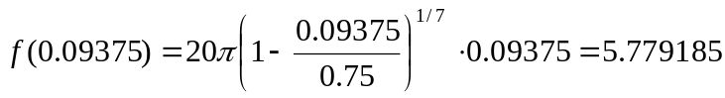
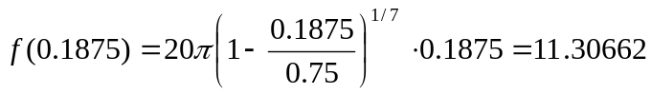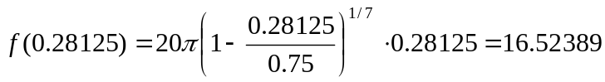
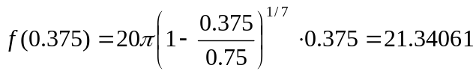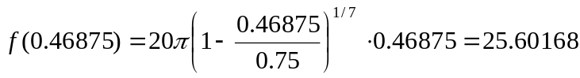
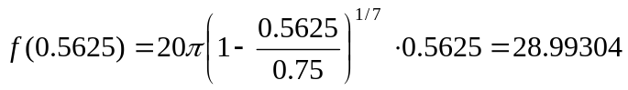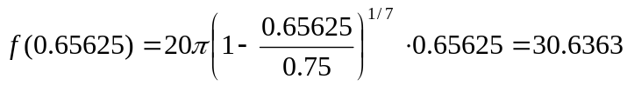
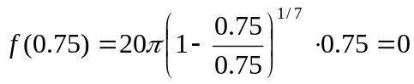
Using trapezoidal rule to calculate integrals,
n=1, h=0.75, 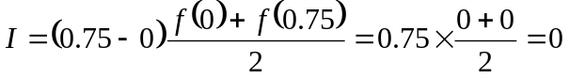
n=2, h=0.375,
n=4, h=0.1875,
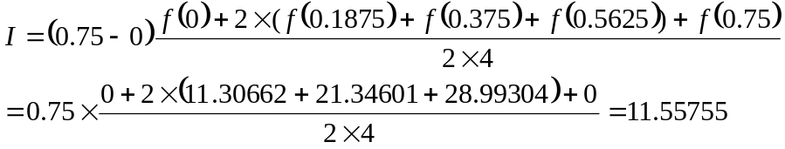
n=8, h=0.09375,
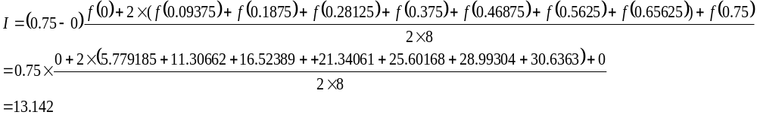According to Romberg integration:
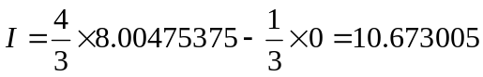
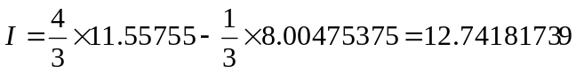
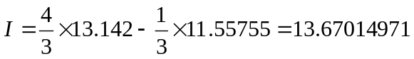
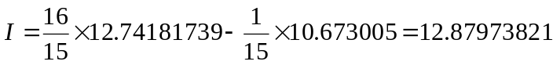
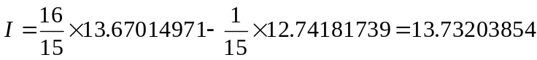
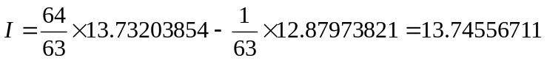
O(h²) | O(h⁴) | O(h⁶) | O(h⁸)
0  8.00475375 | 10.673005
0  8.00475375  11.55755 | 10.673005  12.74181739 | 12.87973821
0  8.00475375  11.55755  13.142 | 10.673005  12.74181739  13.67014971 | 12.87973821  13.73203854 | 13.74556711
Tolerance: 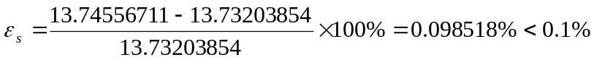
(b). two-point Gauss-Legendre formulas: upper limit b=0.75, lower limit a=0
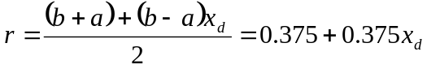
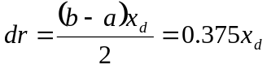
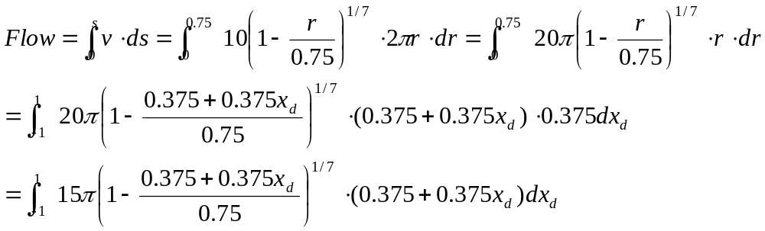
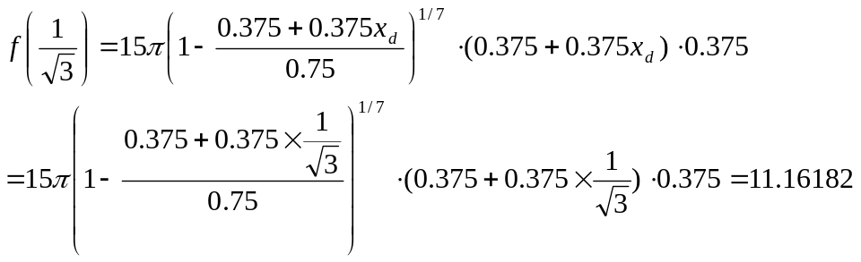
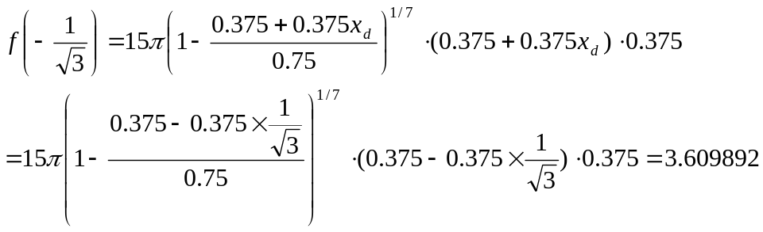
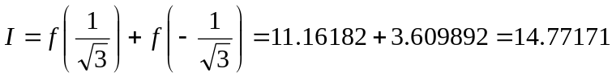
(c). Use Matlab to solve:
>> format long
>> flow=@(r) 20*pi*r.*((1-r/0.75).^(1/7))
flow =
@(r)20*pi*r.*((1-r/0.75).^(1/7))
>> quad(flow,0,0.75)
ans =
14.431685608362534
18.19
Solution: Simpson’s rule:
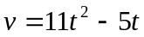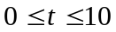
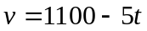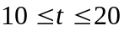
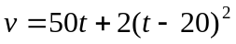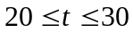
10 segments, Composite Simpson’s 1/3 rule is applied.
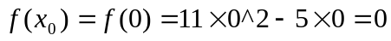
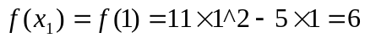
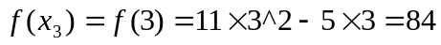
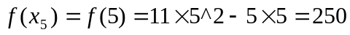
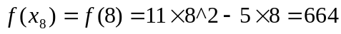
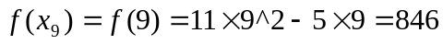
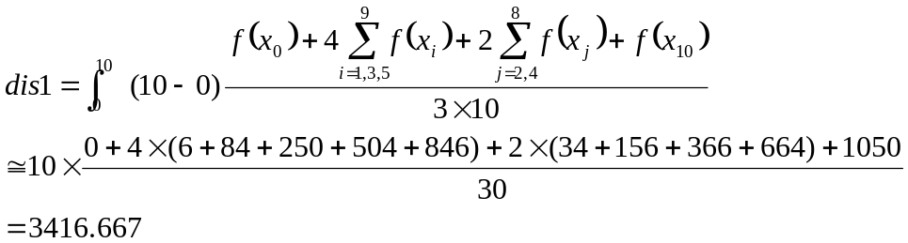
Likewise, 10 segments, Composite Simpson’s 1/3 rule is applied.
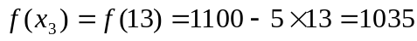
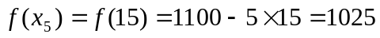
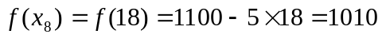
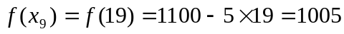
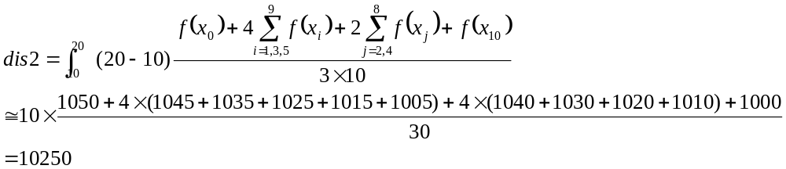 10 segments, Composite Simpson’s 1/3 rule is applied.
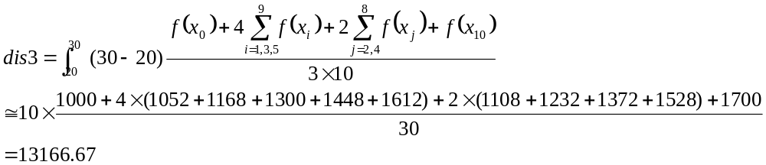Therefore, the total vertical distance traveled by the rocket should be
18.21(a).
Solution:
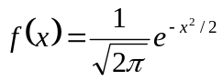
(a). Use Matlab to integrate:
-1 to 1:
>> format long
>> func=@(x) (1/sqrt(2*pi))*exp(-x.^2/2)
func =
@(x)(1/sqrt(2*pi))*exp(-x.^2/2)
>> quad(func,-1,1)
ans =
0.682689491690614
-2 to 2:
>> quad(func,-2,2)
ans =
0.954499794857669

